**Team OneTen**

**Retrospective Artefacts**

* **Iteration 2 -**

**9th October 2022**

**Team OneTen**

* Rui Qin 30874157
* Shangqian Du 31121632
* Pei Ern Cassandra Tong 31509509
* Eugene 27841898
* Daniel Phelan 29732638

<https://miro.com/app/board/uXjVPZU0Ibo=/>

Retrospective Board - Main

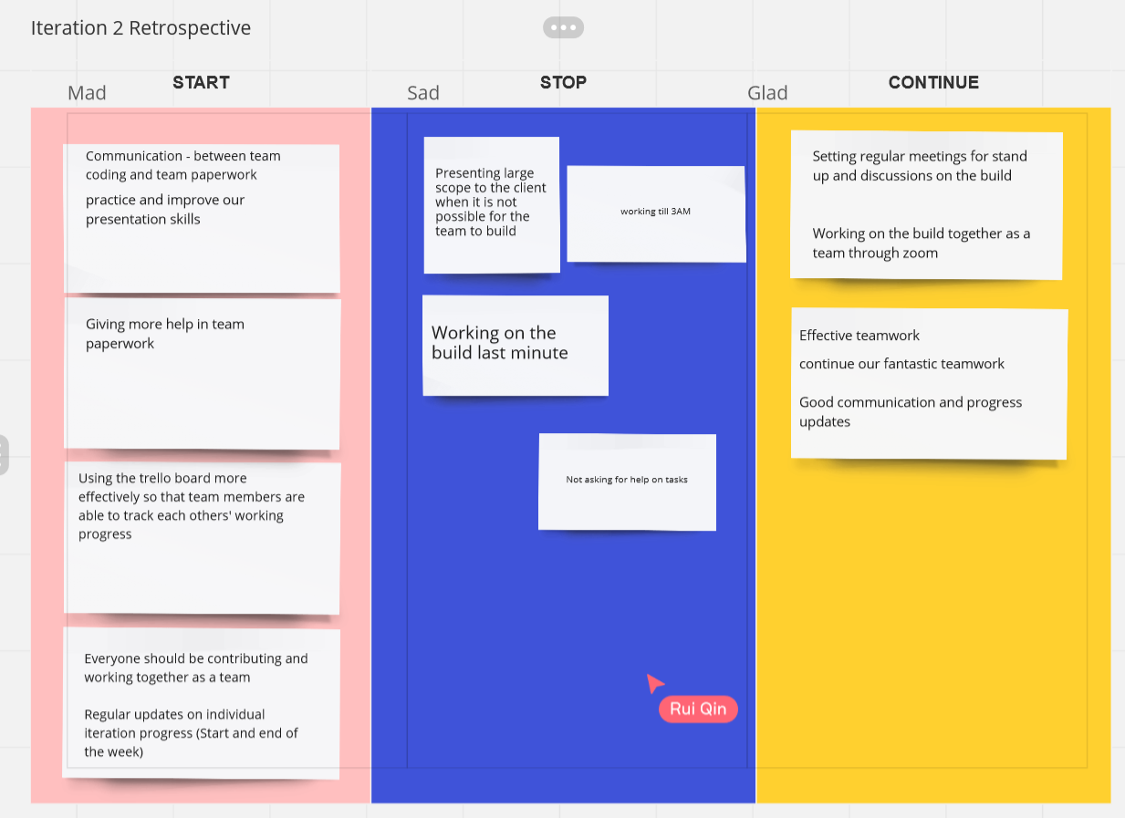

Retrospective Board - Side thoughts:

